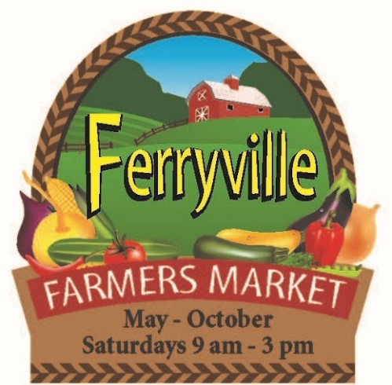
Ferryville Farmers Market
REGISTRATION FORM 2023
PRINT Name____________________________________
Street Address_____________________________
City__________________ State_____ Zip______
Phone: ( )-____ - ____ Cell: ( )-____ - _____
Email:____________________________________
Products to be sold:_________________________
Dates you plan to attend:____________________
Fee: $10.00/day. Season Pass $75. Electrical Fee $3/day if used
Season – May 20 – Oct. 28
Sept. 16 - Fall Fest Fee is $25 weekly vendors / $20 Season Vendors
Checks payable to Ferryville Farmers Market. $35 charge for NSF checks
Attn: Janelle Anderson, 58714 Buck Creek Road, Ferryville, WI 54628
Cell: (715) 216-1411 Email – janelleanderson79@yahoo.com

Or Sherry Quamme, 14767 Eagle Ridge Road, Ferryville, WI 54628
Cell: (920)-210-4560 Email: squamme43@gmail.com

